RRS Cost Optimization Service

The cost of the public cloud is increasing. Executives estimate that at least 32 percent of their cloud spending is wasted, up from 30 percent last year.
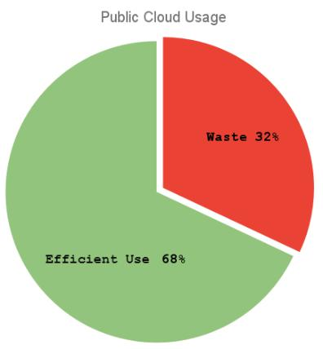
We can curtail this wastage by implementing sound design principles and best practices for cloud workloads. Our expert cloud architects help you find ways to run your workload utilizing the best-fitted services.

The deliverable for this service is a detailed report of how your organization can adopt specific policies, and implement our recommendations, thus optimizing your cloud usage.

Service Highlights

A summary of activities completed by our cloud experts to help to optimize your cloud cost:

- Detailed analysis of cost and usage for all accounts: Our AWS/Azure Certified Architects go beyond respective Cost Explorer and use custom tools to generate summary and detailed reports that let information sliced/dice and group cost by regions, accounts, and services, usage types, and various custom cost categories. We use detailed programmatic access to billing data, generate every kind of report and comparison chart, and detect anomalies in costing.

- Review Existing Pricing Models: Usage and reservation analysis shows potential savings and amortizing one-time expensive purchases. Polling of reservation capacity and unused compute power results in extensive cost savings.

- Review Architecture for Rightsizing: Review if right/appropriate use of serverless and microservices architect is in place. Enabling Autoscaling, Auto-scaling policies, and users can save a lot of money. Serverless and gateway applications are reviewed for purchased compute power, and scaling procedures are adjusted for optimal cost. Kubernetes Clusters are right-sized using Cluster auto scalers and horizontal pod autoscaler to relinquish unused capacity and spot instances for long-running background jobs. We tune and optimize every primary AWS/Azure service, as well as all ingress and egress endpoints. We review and optimize all data transfers outside designated regions.
- Review Operational excellence: Review the IAC Code to reconstitute the environment. IAC Code reduces infrastructure provisioning time; only well-tested resources are provisioned in production environments. Review application CICDs. Cost inefficiencies in the cloud and containerized applications' build and deployment processes are relatively common, and review existing deployment run books and prod deployment.
- Other Cost Optimization Areas: Our experts know a few advanced cost-saving tricks of the trade, for example, using NAT instances for nonproduction environments rather than expansive NAT gateways or when using Provisioned IOPs for EBS and when using Transit gateways to reduce bandwidth charges, etc. They know how to hunt down the last zombie and orphan resource or efficiently use spot instances for scheduled workload and other cost-saving strategies.

- Alerts and account structure: We provide advice and steps to set up advanced alerts, create AWS/Azure organization and develop resource-sharing accounts and organizations.

Tools we Use

Here are some tools we use for AWS usage & cost optimization discovery.

- AWS Programmatic access to get detailed line items for billing

- AWS Cost Explorer / Azure Billing Tool

- Custom scripts to generate usage, reservation analysis, and anomalies detection

- AWS Trusted advisor

RRS Advantage

We enable you to take control of compute costs and continuously optimize your spending while your team builds secure, scalable, and modern applications to maximize your ROI. We have saved companies thousands of dollars in billing and provided excellent recommendations to save on all types of application models. We pay special attention to unused and oversubscribed capacity and common wasteful patterns without any analysis to reserve needed power for applications.

For Additional Information

For any additional inquiries please send email at mailto:contact@rockyroadsolutions.com and out team will contact you within 1 to 2 business days.

